TESTING THE WEB UI BY GIVING REQUIRED INPUTS

TEAM ID :PNT2022TMID00940

Web UI Interface:

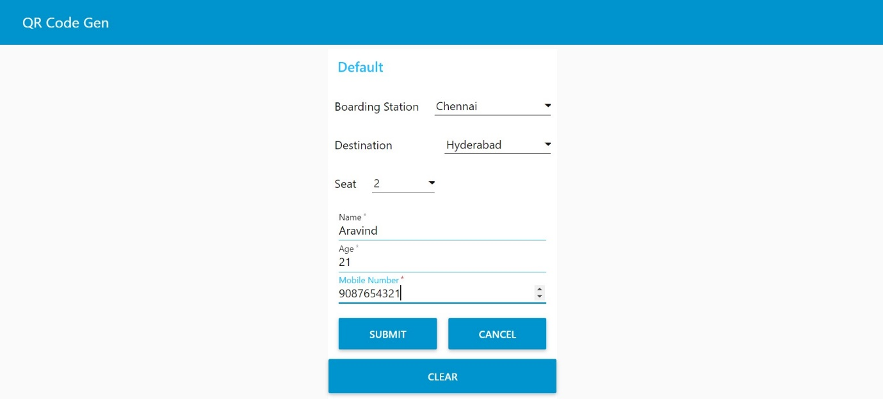

Generation of QR:

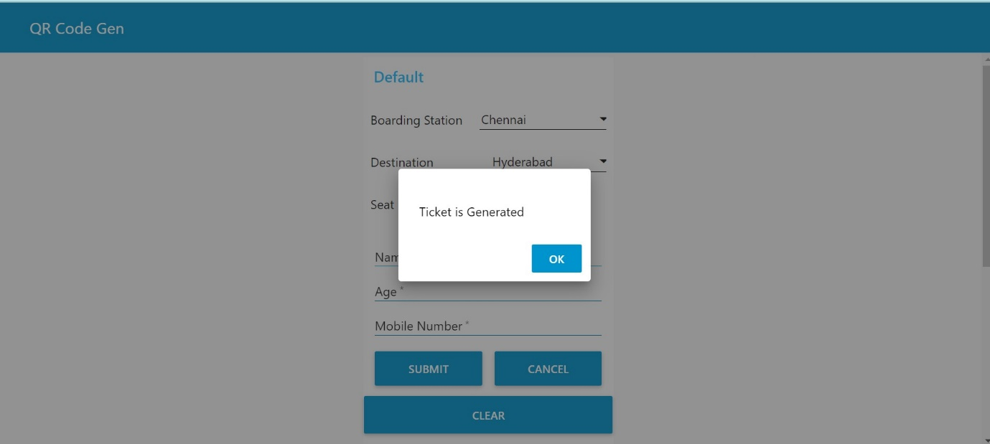

Generated QR:

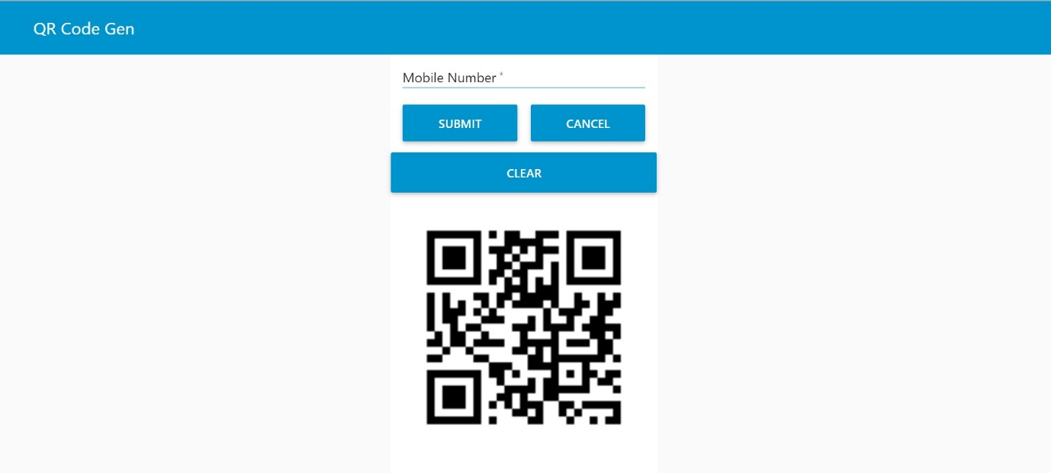

Scanning QR:

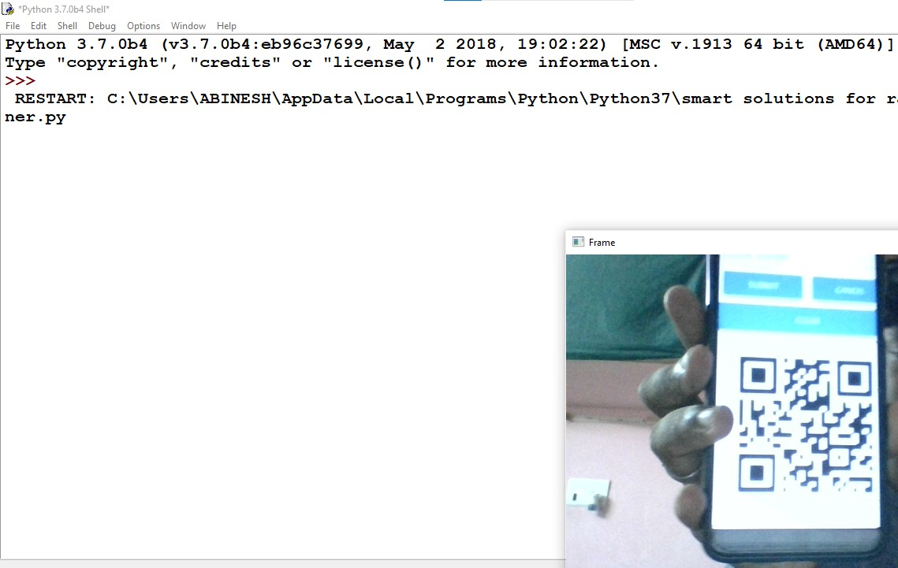

Output:

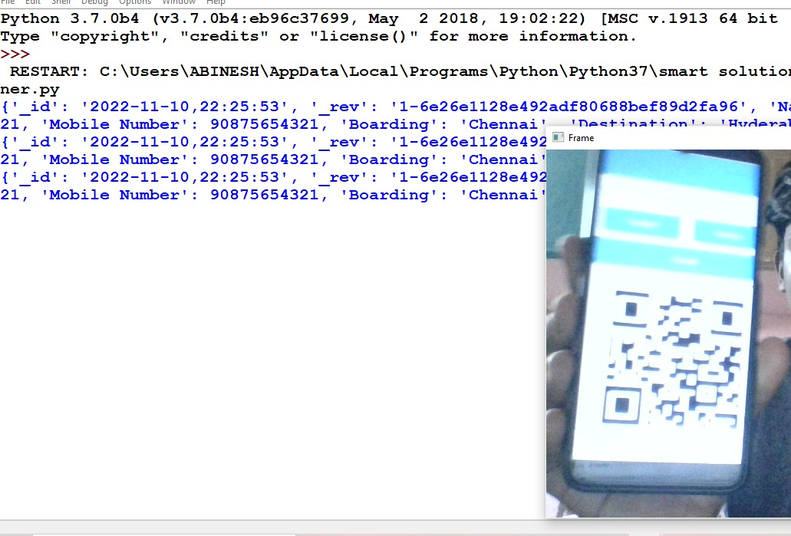

Output after showing the right ticke

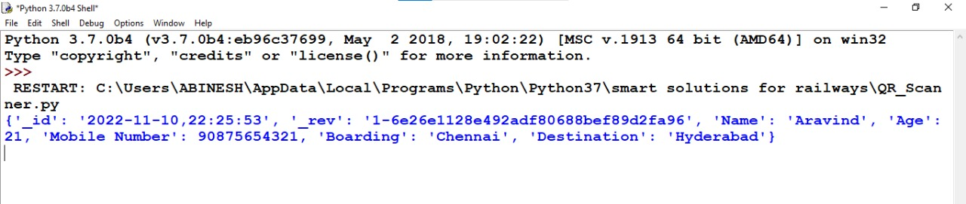

Output after showing the wrong QR:

